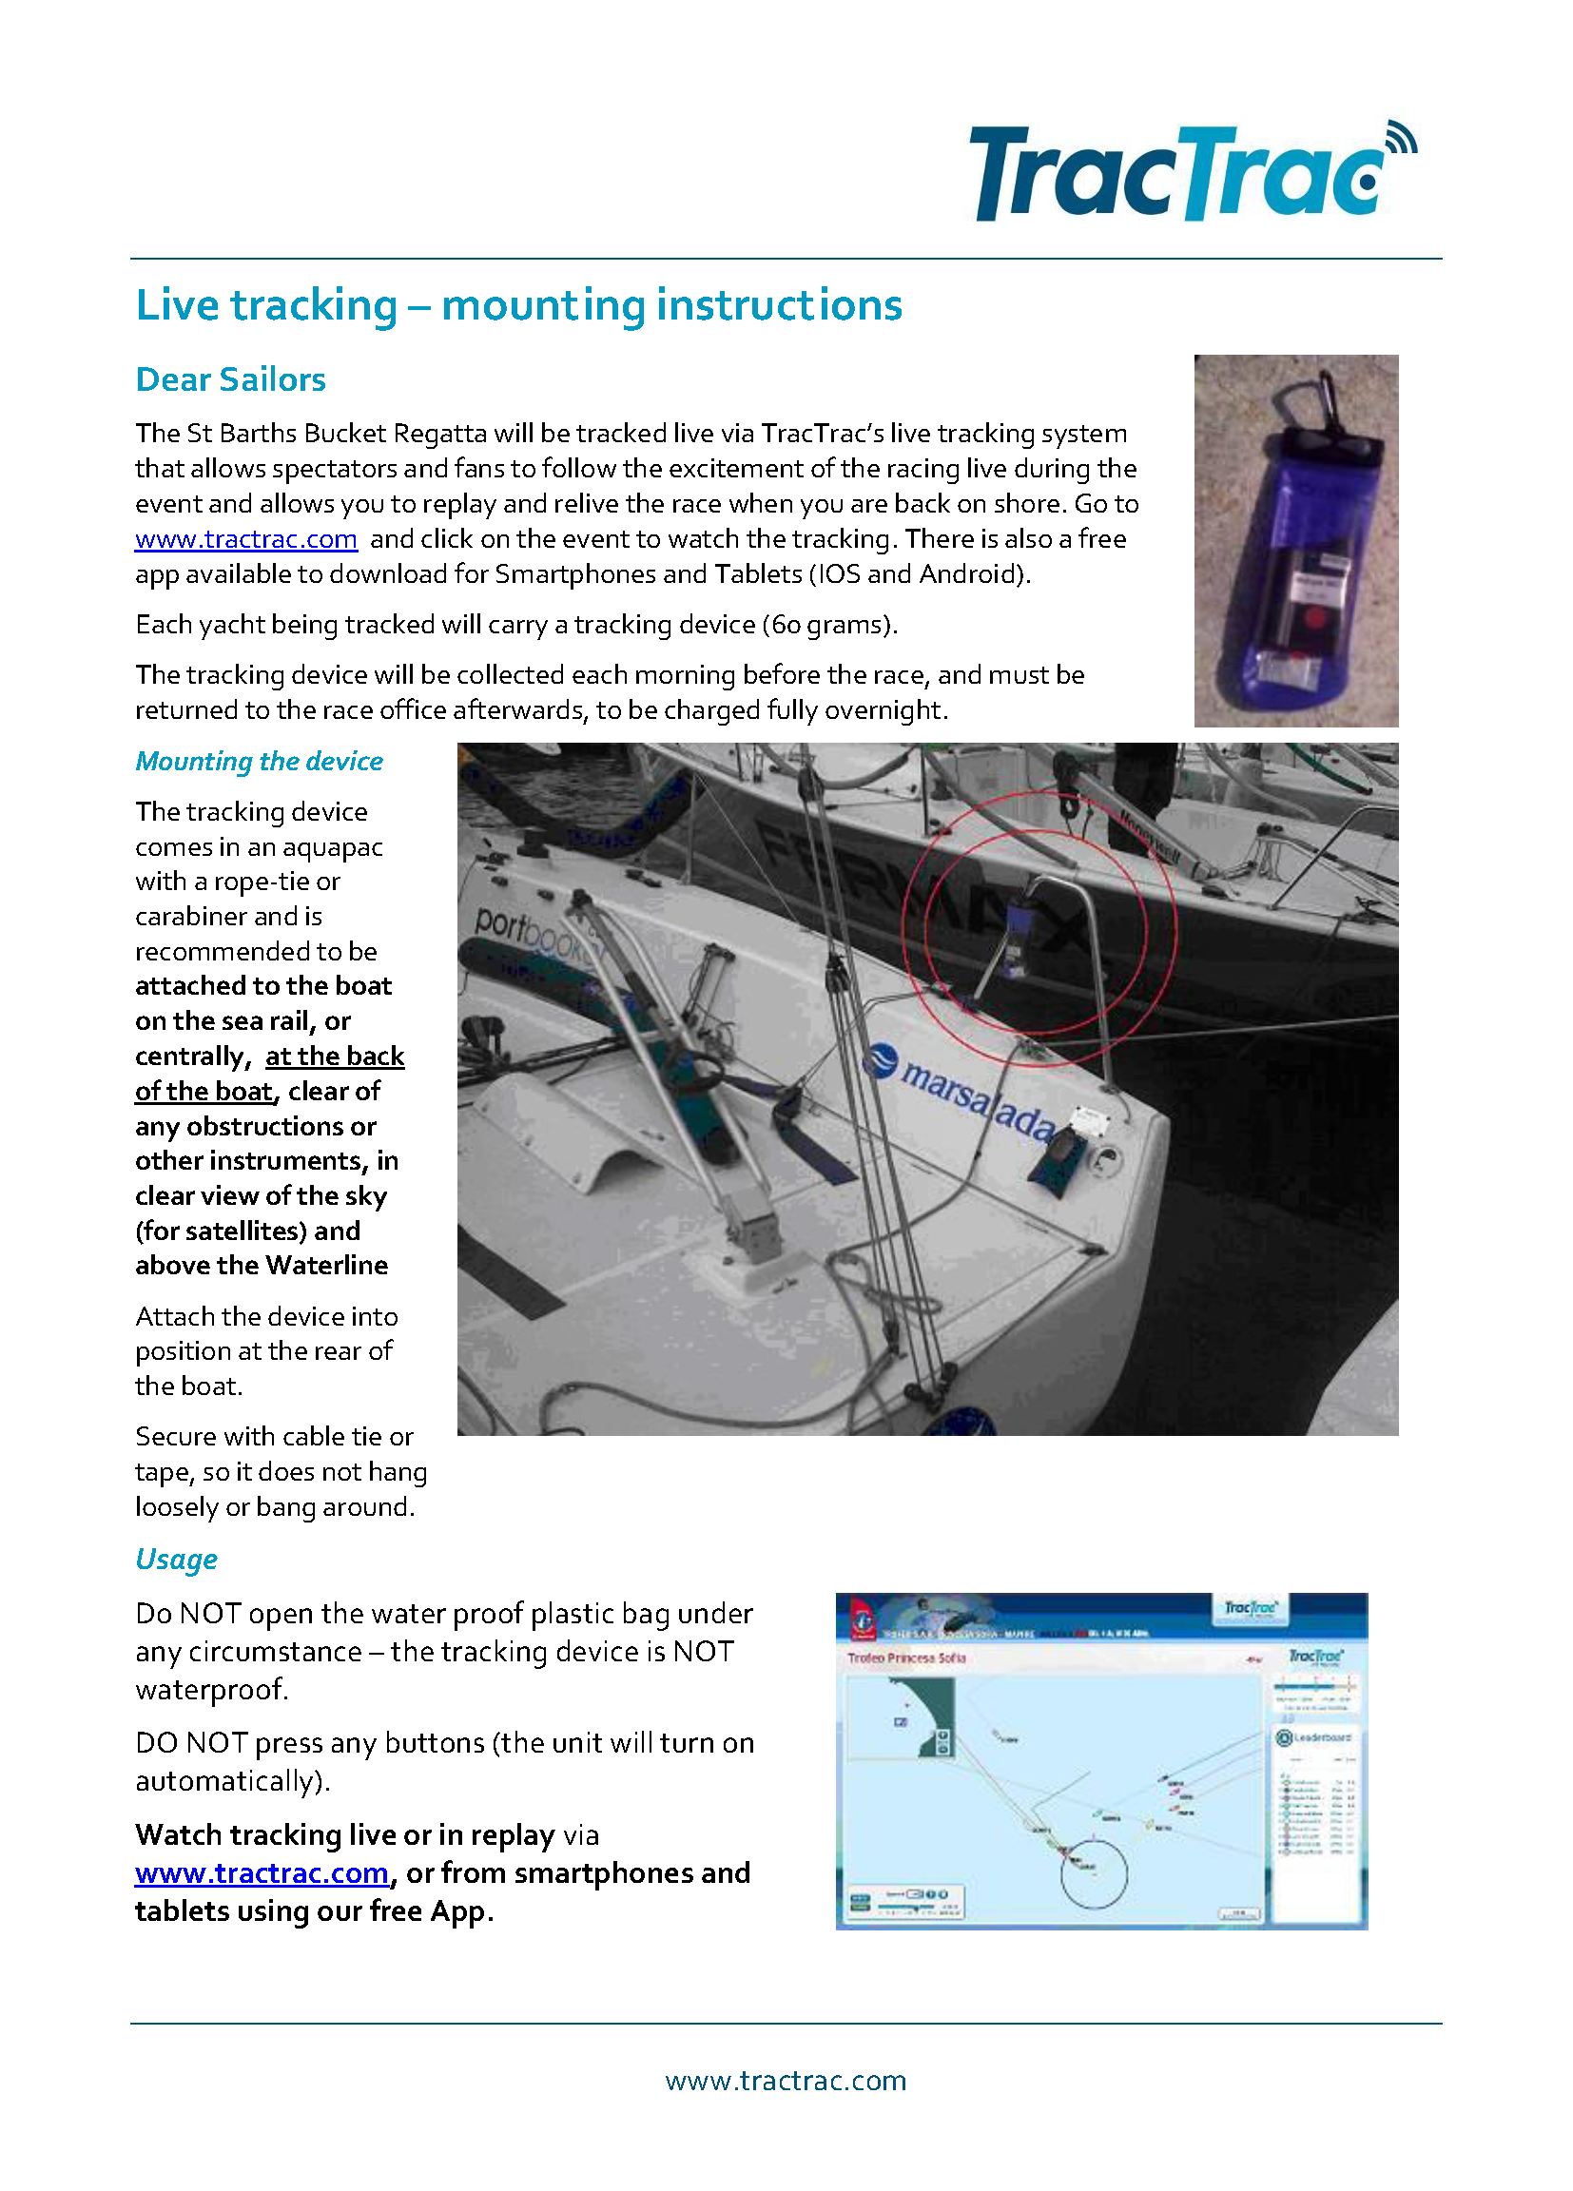
www.tractrac.com

EVENT NAME – GPS Tracker Instructions – Sailing Instructions Exhibit X

